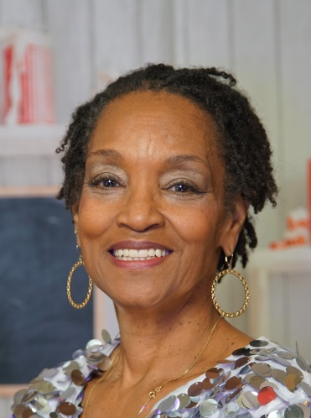Evangelist Beverly Trotter was born in Grand Rapids, Michigan and raised in Gary Indiana. Beverly was raised in a good Christian home but decided that she was missing out on life and needed to see what the other side was like. To a rude awakening life became a world of drugs, alcohol and promiscuous living. At the age of 30, God came in and captured my heart; and today I’m always looking for places to share the gospel of Christ.

Beverly is married to Pastor, Emmit Trotter and are the proud parents of six children and 16 grandchildren. Moving to the Twin Cities in 1999 from Grand Rapids, Michigan where she was a faithful member of Anointed Ministries Church of God in Christ and I’m now a faithful member of Faith Tabernacle Ministries, where Supt. Bruce DeArmon is the senior pastor. The Lord has blessed Beverly with many gifts and a burning burden for women and children who are hurting, searching and finding no rest. It was only a few decades ago when that woman was me. I’ve made a vow to God to share with men, women and children everywhere about his grace, mercy and love.

I have been evangelizing through the following ministries:

|  |
| --- |
| * **1996-1999 Kent County Correctional Facility Grand Rapids, MI** * **1997-Present Crossroads Correspondence Prison Ministry Grandville, MI** |
| * **2015-2015 Waceca Women's Correctional Facility Waseca, MN** * **2013-Present Faith Tabernacle Church of God in Christ Minneapolis, MN** |

* **2005** **Help A Sista’ Out Ministries Minneapolis, MN**

Not only has God graced me with the ability to do ministry, but to be able to help people to fulfill their dreams and ambitions. Often by the time we’ve hit bottom we feel like there is no better life for us; and I’ve found that that is so far from the truth. That’s when God can really use us. That is when He picks us up out of the miry clay and finishes the purpose that He had planned for us all along. We just need guidance to Him, spiritually as well as physically.

Beverly teaches computer skills, work ethics, to help others gain the skills needed for employment, the gift to encourage, and to teach others to love themselves, so that they can in turn love others. But most of all He’s given me a testimony that proves every day that he is Lord.

Help a Sista' Out Ministries did a10 well pilot project at the women's correctional facility under the federal jurisdiction. It was very enlightening for all. It was a humbling experience for me as well as the team. To God be the glory.